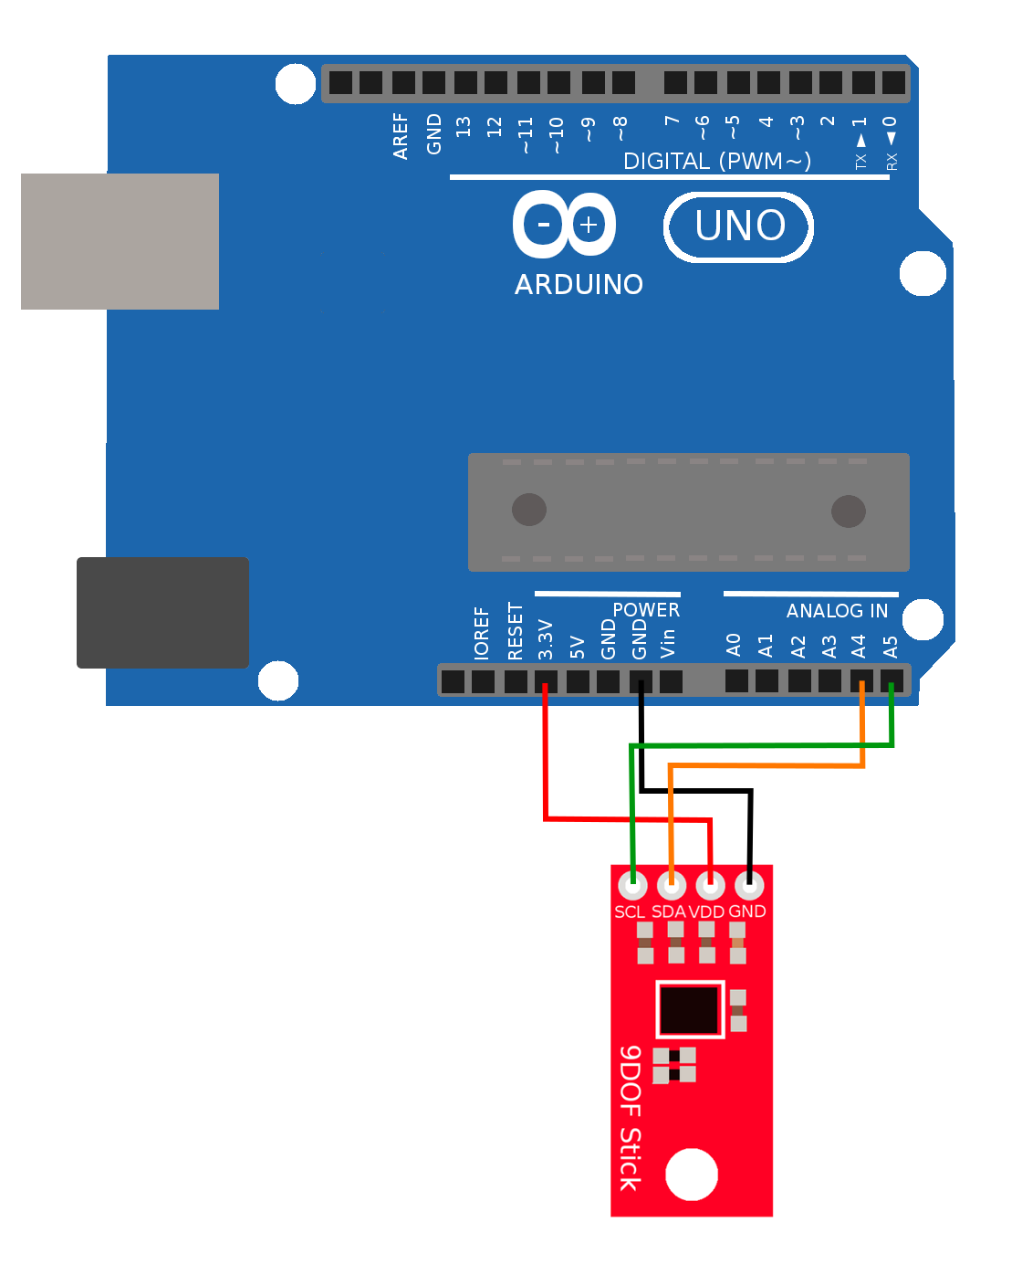
Wiring and Testing the Light Sensor

